160210/PJ

Reesbe routines upon registration of PhD courses in LADOK

For doctoral students admitted at HiG, Academy of Technology and Environment (ATM):

- The course is given at HiG
the course coordinator (teacher) e-mails to the LADOK coordinator at the academy a list of the doctoral students admitted at the academy which have passed the course
the doctoral student submits to the LADOK coordinator at the academy the completed form Rapportering av intern forskarutbildningskurs (in Swedish) signed by the primary supervisor

NOTE! The form is to be completed on computer (pdf format). The picture below is only for information:

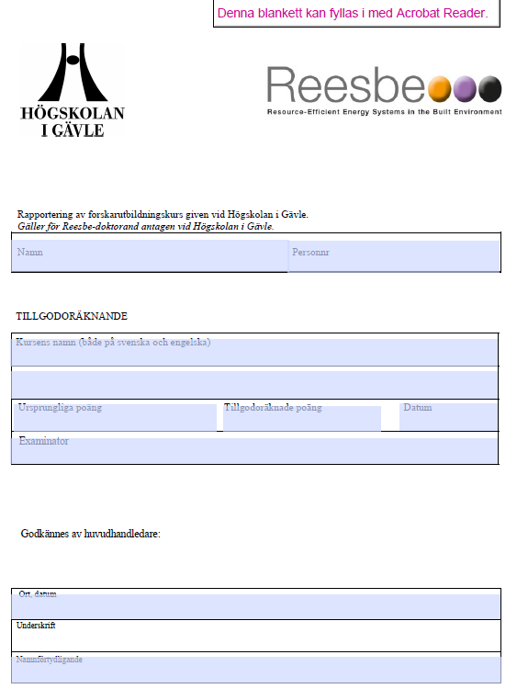
http://www.hig.se/download/18.7a0bbb1714aed50f6985b52e/1422363319632/Rapportering+av+f-kurs+vid+HiG.pdf

- The course is given at another university
the course coordinator (teacher) e-mails to the LADOK coordinator at the academy a list of the doctoral students admitted at the academy which have passed the course and hands out course certificate to the respective doctoral student
the doctoral student submits to the LADOK coordinator at the academy the completed form Registrering av forskarutbildningspoäng – Tillgodoräknande (in Swedish) signed by the supervisor as well as the course certificate handed out by the course coordinator (teacher)

NOTE! The form is to be completed on computer (pdf format). The picture below is only for information:

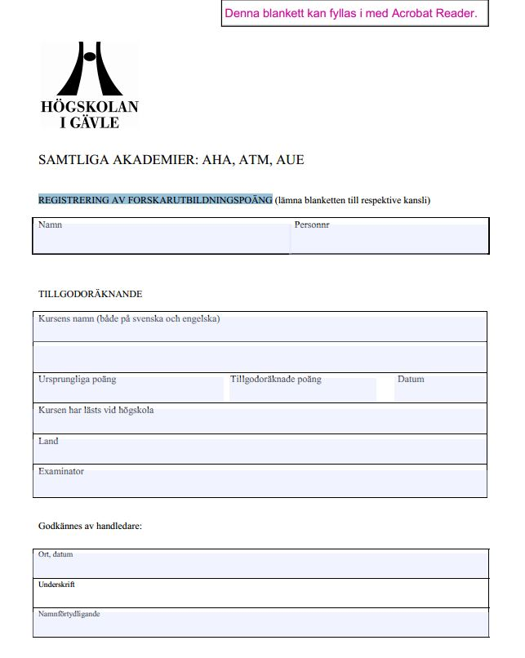
https://www.hig.se/download/18.5f495d1b139d3aaa73b8000157/1353628792603/KursTillgodoBlankett.pdf

For doctoral students admitted at MDH, The School of Business, Society and Engineering (EST):

- The course is given at MDH
the doctoral student submits to the LADOK coordinator at the academy the completed form Rapportering av kurs for utbildning på forskarnivå (in Swedish) signed by the examinator and the primary supervisor

NOTE! The form is to be completed on computer (pdf format). The picture below is only for information:

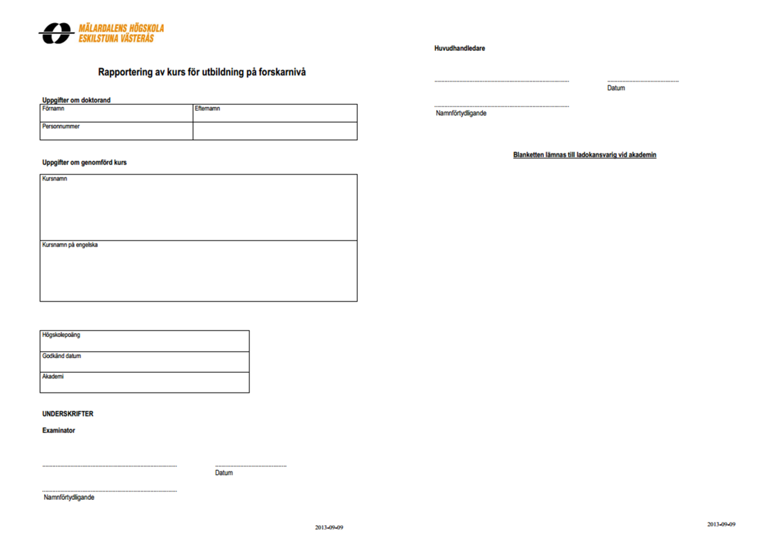
https://www.mdh.se/polopoly_fs/1.44899!/Menu/general/column-content/attachment/Rapport%20av%20kurs%20Final.pdf

- The course is given at another university
the course coordinator (teacher) submits to the LADOK coordinator at the academy a signed list of the doctoral students admitted at the academy which have passed the course or hands out course certificate to the respective doctoral student
the doctoral student submits to the LADOK coordinator at the academy the completed form Ansökan om tillgodoräknande for utbildning på forskarnivå (in Swedish) signed by the doctoral student personally and, when applicable (see above), the course certificate handed out by the course coordinator (teacher)

NOTE! The form is to be completed on computer (pdf format). The picture below is only for information:

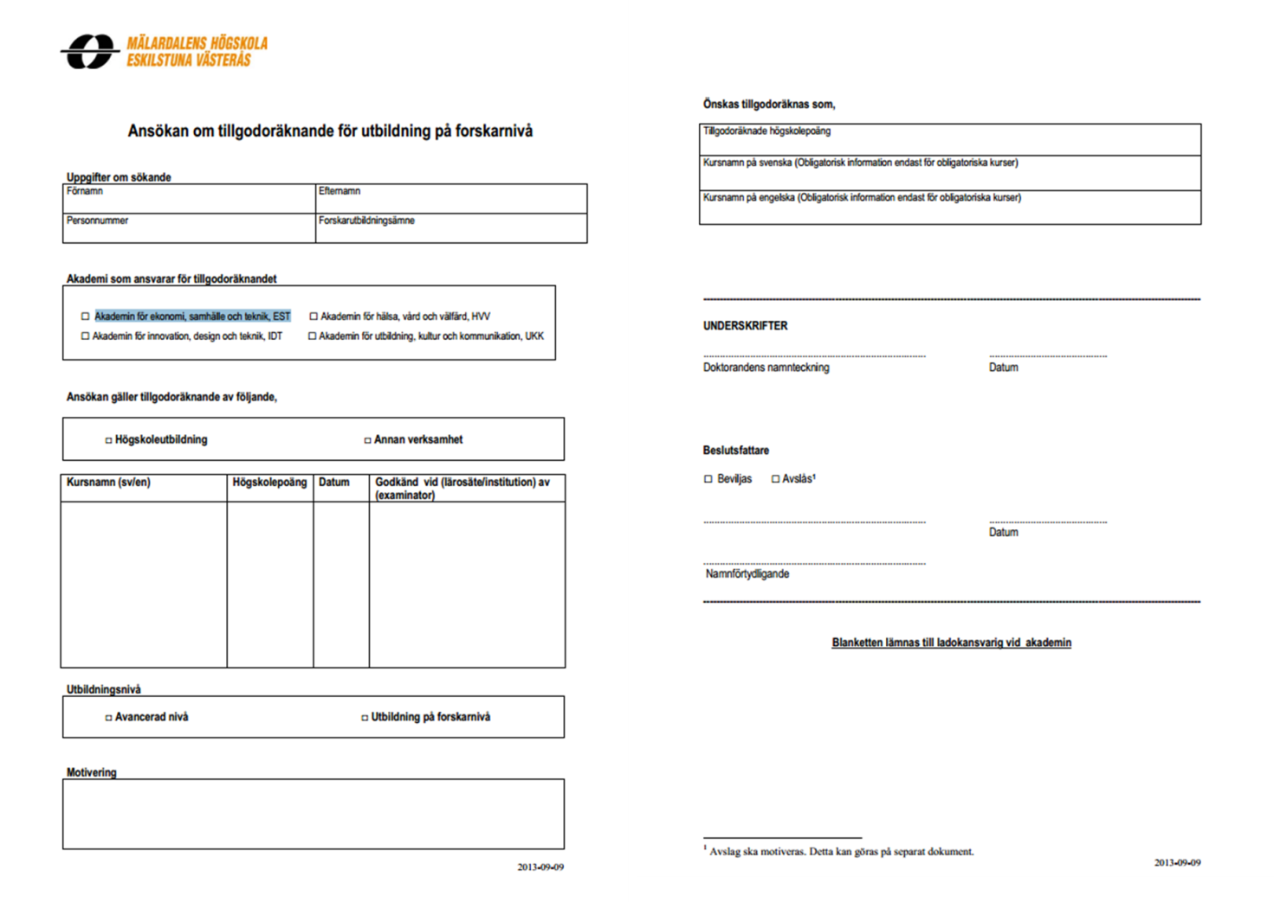
https://www.mdh.se/polopoly_fs/1.47091!/Menu/general/column-content/attachment/Ansokan%20om%20tillgodoraknande%20Final.pdf

